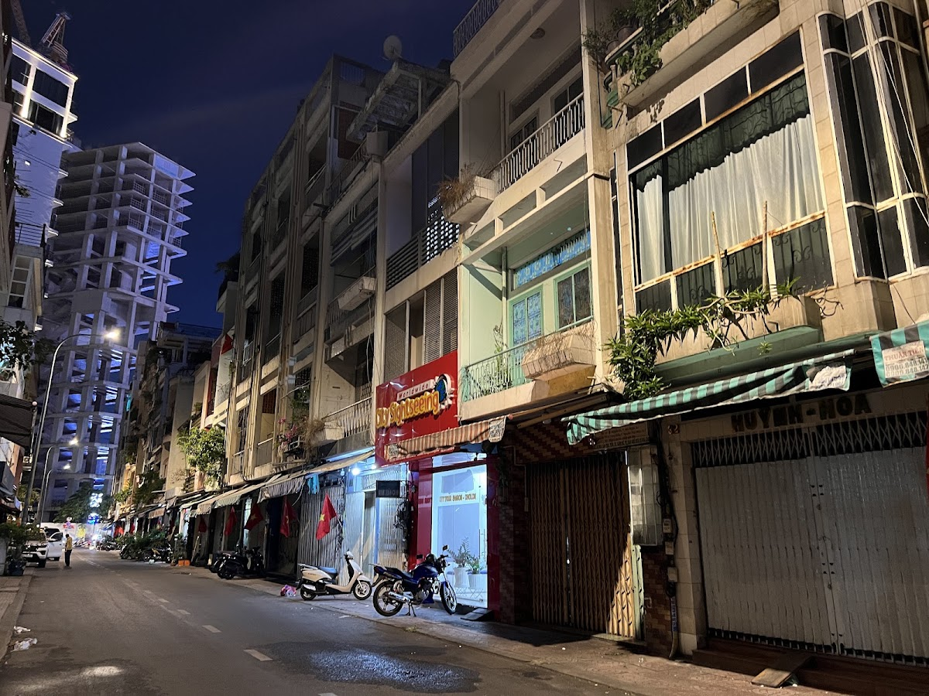

JAPAN ACCOMMODATION RECOMMENDATIONS
Curated by Bon Voyage By Marina
Prepared Exclusively For
DO NOT SHARE- ROCHAK
TRIP SNAPSHOT
Destination | Japan
Travellers | 1 room- 2 adults + 1child (4 yrs)
Stay Requirements | Refundable Booking • Breakfast Included

A NOTE FROM BON VOYAGE BY MARINA
Thank you for giving us the opportunity to assist with your Japan journey. The options in this document have been carefully reviewed and shortlisted based on your preferences, location requirements, flexibility, and overall value. We hope this guide helps you choose the stay that is right for you.

Bon Voyage By Marina
Bespoke Travel Planning • Premium Stays • Seamless Experiences
📞 +91 86000 15316 | 📸 @bonvoyagebymarina | 🌐 www.bonvoyagebymarina.com
✈️ Crafting unforgettable journeys, one trip at a time.

Executive Summary
Compare all accommodation options at a glance.
Plan | Hotels | Best Online Price | Our Price | You Save
Plan A | • Via Inn Prime Kyotoeki Hachijoguchi (3*)  • HOTEL MYSTAYS Fuji Onsen Resort (3*)  • Grand Nikko Tokyo Daiba (5*) | ₹2,42,112 | ₹2,25,112 | ₹17,000  (7.0% off)
Plan B  ★ RECOMMENDED | • Mercure Kyoto Station (4*)  • HOTEL MYSTAYS Fuji Onsen Resort (3*)  • Grand Nikko Tokyo Daiba (5*) | ₹2,68,928 | ₹2,47,428 | ₹21,500  (8.0% off)

PLAN A

Via Inn Prime Kyoto Station Hachijo Exit

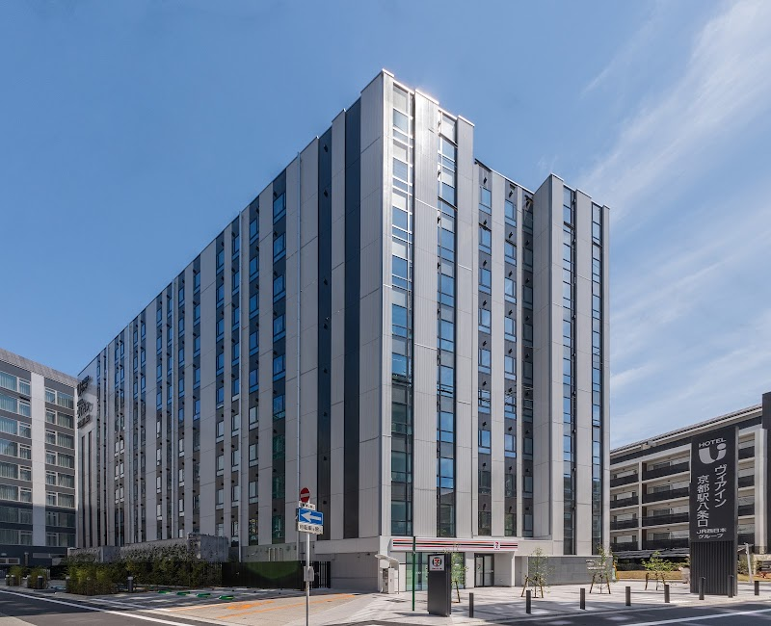
🛏️ Room: Deluxe Double Room
📅 Check-in / Check-out: Nov 17 -22
🏨 Category: 3
⭐ Guest Rating: 4.3/5 (1,792 reviews)
🔄 Cancellation: Free cancellation till 14 Nov
🍳 Breakfast: Breakfast included
Positioned directly at Kyoto Station's Hachijo Exit, this well-regarded property places you within immediate reach of the city's most iconic temples, shrines, and cultural landmarks — with Shinkansen connections to Osaka and Tokyo equally convenient. A 4.3 rating across nearly 1,800 reviews speaks to consistent, reliable delivery. Breakfast is included, giving you a grounded start before each day of exploration. The hotel suits travellers who prioritise location and ease of movement above all else — a sensible base for a city best experienced by getting out into it. Free cancellation is available until 14 November.

HOTEL MYSTAYS Fuji Onsen Resort

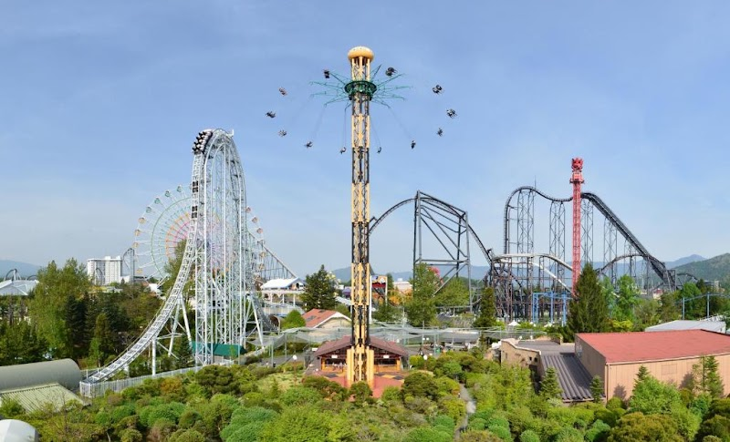
🛏️ Room: comfort twin room
📅 Check-in / Check-out: Nov 22 -24
🏨 Category: 3
⭐ Guest Rating: 4.3/5 (3,156 reviews)
🔄 Cancellation: Free cancellation till 18 Nov
🍳 Breakfast: Breakfast included
Tucked into the foothills of Mount Fuji in Fujiyoshida, HOTEL MYSTAYS Fuji Onsen Resort places you at the heart of one of Japan's most iconic landscapes. The resort draws families and couples seeking a genuine onsen experience alongside easy access to the Fuji Five Lakes region and Chureito Pagoda. Guests consistently rate it highly across over 3,000 reviews, and the inclusion of breakfast alongside a free cancellation policy until 18th November makes planning straightforward. For a stay that balances natural surroundings, traditional bathing culture, and reliable comfort, this property delivers with quiet confidence.

GRAND NIKKO TOKYO DAIBA

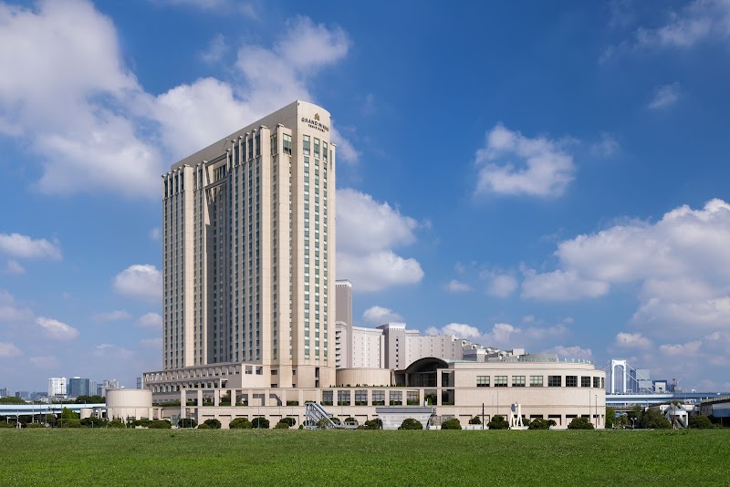
🛏️ Room: Premier Floor Superior Double, Non Smoking
📅 Check-in / Check-out: Nov 24 -26
🏨 Category: 5
⭐ Guest Rating: 4.4/5 (9,327 reviews)
🔄 Cancellation: Free cancellation till 21 Nov
🍳 Breakfast: Breakfast included
Perched on the waterfront of Odaiba, Grand Nikko Tokyo Daiba offers sweeping views of Tokyo Bay and the iconic Rainbow Bridge — a setting that feels removed from the city's intensity while remaining well connected to it. This is a hotel that suits travellers who want scale, polish, and a sense of occasion, with breakfast included and a strong guest rating across nearly ten thousand reviews. Free cancellation until 21st November allows flexibility in your planning. The bay views alone make this a memorable base for exploring Tokyo.

Online Price | ₹2,42,112
Our Price | ₹2,25,112
You Save | ₹17,000 (7.0% off best online prices)

PLAN B ★ RECOMMENDED

Why we recommend it: Lorem Ipsum is simply dummy text of the printing and typesetting industry. Lorem Ipsum has been the industry's standard dummy text ever since 1966, when designers at Letraset and James Mosley, the librarian at St Bride Printing Library in London, took a 1914 Cicero translation and scrambled it to make dummy text for Letraset's Body Type sheets. It has survived not only many decades, but also the leap into electronic typesetting, remaining essentially unchanged. It was popularised thanks to these sheets and more recently with desktop publishing software like Aldus PageMaker and Microsoft Word including versions of Lorem Ipsum.
Mercure Kyoto Station

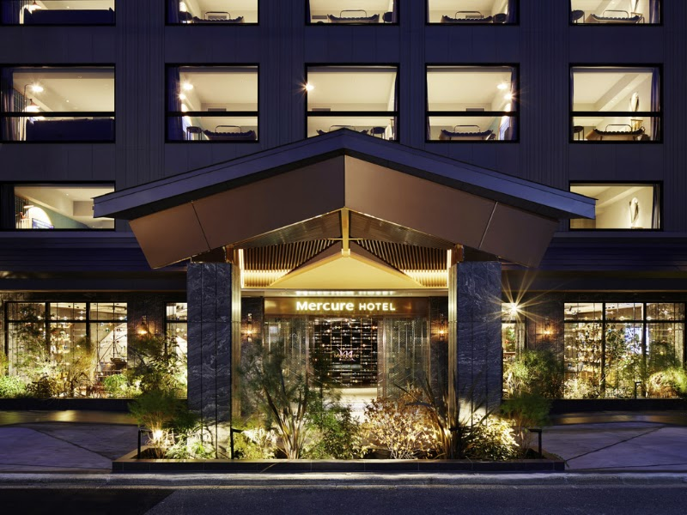
🛏️ Room: Superior Room with 1 King bed
📅 Check-in / Check-out: Nov 17 -22
🏨 Category: 4
⭐ Guest Rating: 4.4/5 (1,785 reviews)
🍳 Breakfast: Breakfast included
Positioned just moments from Kyoto Station, Mercure Kyoto Station places you at the city's most connected hub — with direct rail access to Osaka, Nara, and beyond, and the iconic temples of Fushimi Inari and Toji within easy reach on foot or by a short ride. The hotel carries Mercure's signature blend of local character and reliable comfort, making it particularly well-suited to travellers who want a central base without sacrificing warmth or personality. Breakfast is included, and a strong guest rating of 4.4 across nearly 1,800 reviews speaks to consistent, attentive service. A dependable and well-located choice for exploring Kyoto at your own pace.

HOTEL MYSTAYS Fuji Onsen Resort


🛏️ Room: comfort twin room
📅 Check-in / Check-out: Nov 22 -24
🏨 Category: 3
⭐ Guest Rating: 4.3/5 (3,156 reviews)
🔄 Cancellation: Free cancellation till 18 Nov
🍳 Breakfast: Breakfast included
Tucked into the foothills of Mount Fuji in Fujiyoshida, HOTEL MYSTAYS Fuji Onsen Resort places you at the heart of one of Japan's most iconic landscapes. The resort draws families and couples seeking a genuine onsen experience alongside easy access to the Fuji Five Lakes region and Chureito Pagoda. Guests consistently rate it highly across over 3,000 reviews, and the inclusion of breakfast alongside a free cancellation policy until 18th November makes planning straightforward. For a stay that balances natural surroundings, traditional bathing culture, and reliable comfort, this property delivers with quiet confidence.

GRAND NIKKO TOKYO DAIBA


🛏️ Room: Premier Floor Superior Double, Non Smoking
📅 Check-in / Check-out: Nov 24 -26
🏨 Category: 5
⭐ Guest Rating: 4.4/5 (9,327 reviews)
🔄 Cancellation: Free cancellation till 21 Nov
🍳 Breakfast: Breakfast included
Perched on the waterfront of Odaiba, Grand Nikko Tokyo Daiba offers sweeping views of Tokyo Bay and the iconic Rainbow Bridge — a setting that feels removed from the city's intensity while remaining well connected to it. This is a hotel that suits travellers who want scale, polish, and a sense of occasion, with breakfast included and a strong guest rating across nearly ten thousand reviews. Free cancellation until 21st November allows flexibility in your planning. The bay views alone make this a memorable base for exploring Tokyo.

Online Price | ₹2,68,928
Our Price | ₹2,47,428
You Save | ₹21,500 (8.0% off best online prices)

Thank You
Thank you for giving Bon Voyage By Marina the opportunity to assist with your Japan journey. We hope the accommodation options in this document help you find the stay that best matches your travel style, preferences, and budget.
Should you wish to explore additional options, alternative locations, upgraded room categories, or other travel arrangements, we would be delighted to assist.
We look forward to helping create an unforgettable Japan experience for you.
Warm regards,
Bon Voyage By Marina
Bespoke Travel Planning • Premium Stays • Seamless Experiences
📞 +91 86000 15316 | 📸 @bonvoyagebymarina | 🌐 www.bonvoyagebymarina.com
✈️ Crafting unforgettable journeys, one trip at a time.

